**Assignment-1**

**Code-**

public class Student {

    private String studentName;

    private String collegeName;

    private int studentID;

    public static void main(String[] args) {

        System.out.println("Successful");

    }

}

**Output-**

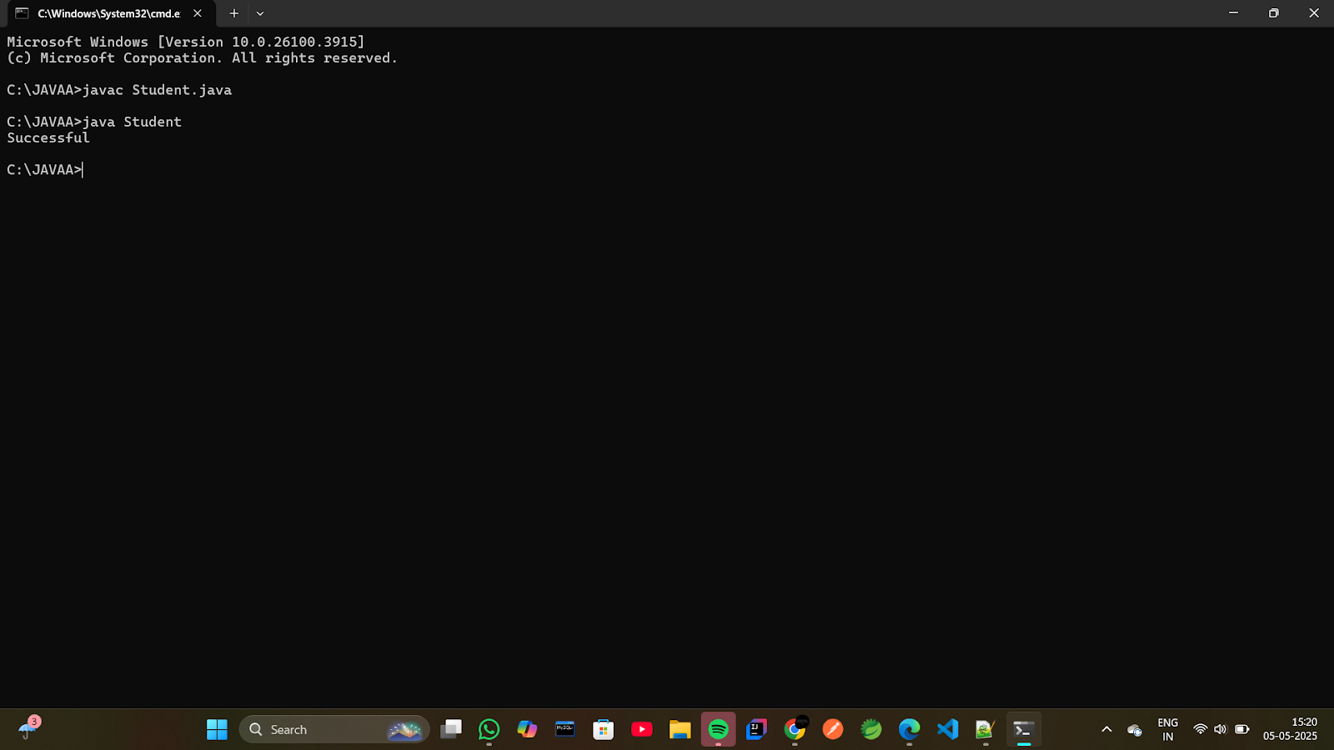

**Assignment-2**

**Code-**

class Employee

{

protected int id;

protected int age;

protected String name;

protected boolean isPermanent;

public static void main(String ar[])

{

Employee e1 = new Employee();

e1.age = (int)35.5;

System.out.println("Successfully started");

}

}

**Output-**

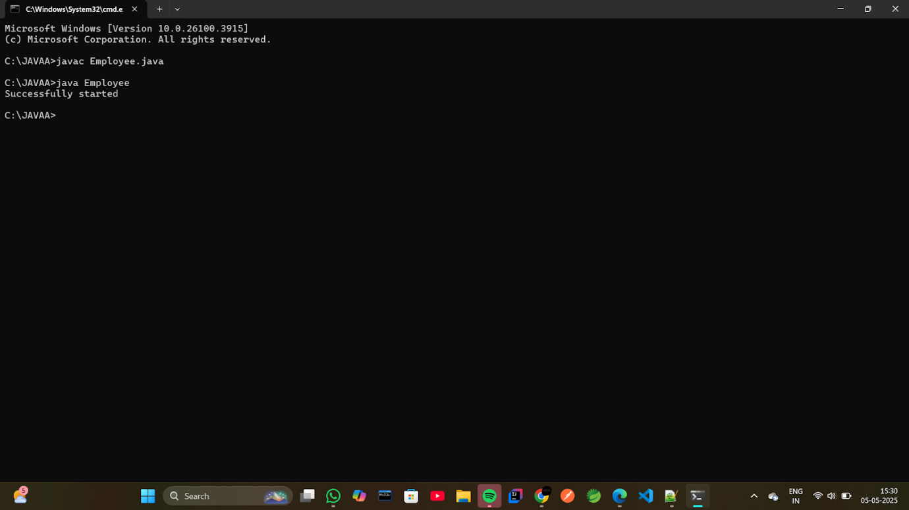

**Assignment-3**

**Code-**

public class Person {

    String name = "Ramji";

    int age = 30;

    int salary = 50000;

    public static void main(String[] args) {

        System.out.println("Test Successful");

    }

}

**Output-**

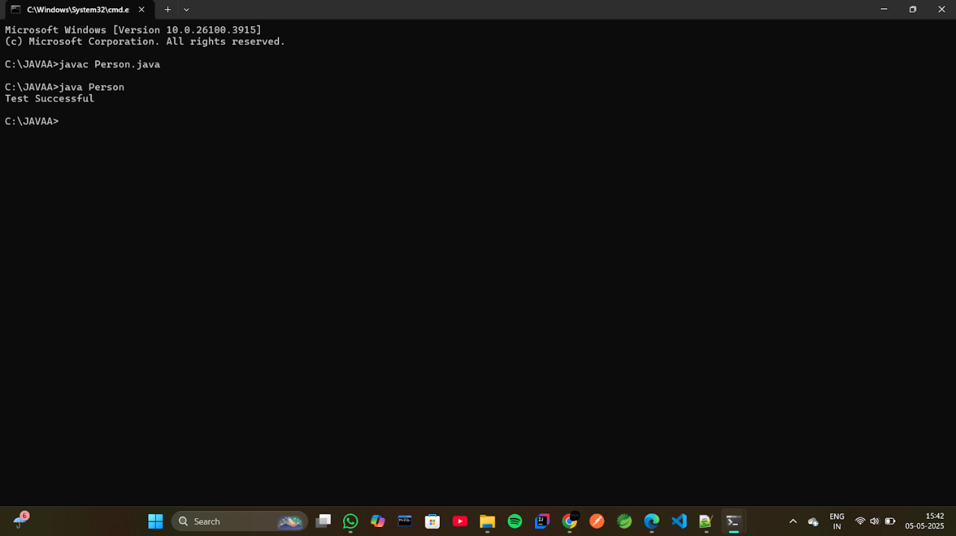

**Assignment-4**

**Code-**

public class Rectangle {

   double width;

    double height;

   enum Color {

        RED, GREEN, BLUE

    }

  Color boxColor;

 public static void main(String[] args) {

          System.out.println(Color.BLUE);

    }

}

**Output-**

